NAME: Ramya Ramesh

USN: 1BM19CS227

**PROGRAM 7: BOOK DEALER DATABASE**

TABLES:

CREATE DATABASE book_dealer;

USE book_dealer;

CREATE TABLE author(

author_id INT,

author_name VARCHAR(20),

author_city VARCHAR(20),

author_country VARCHAR(20),

PRIMARY KEY(author_id));

DESC author;

CREATE TABLE publisher(

publisher_id INT,

publisher_name VARCHAR(20),

publisher_city VARCHAR(20),

publisher_country VARCHAR(20),

PRIMARY KEY(publisher_id));

DESC publisher;

CREATE TABLE category(

category_id INT,

category_desc VARCHAR(30),

PRIMARY KEY(category_id));

DESC category;

CREATE TABLE catalog(

book_id INT,

book_title VARCHAR(30),

author_id INT,

publisher_id INT,

category_id INT,

year INT,

price INT,

PRIMARY KEY(book_id),

FOREIGN KEY(author_id) REFERENCES author(author_id),

FOREIGN KEY(publisher_id) REFERENCES publisher(publisher_id),

FOREIGN KEY(category_id) REFERENCES category(category_id));

DESC catalog;

CREATE TABLE order_details(

order_id INT,

book_id INT,

quantity INT,

PRIMARY KEY(order_id),

FOREIGN KEY(book_id) REFERENCES catalog(book_id));

DESC order_details;

INSERT INTO author VALUES(1001,'JK Rowling','London','England');

INSERT INTO author VALUES(1002,'Chetan Bhagat','Delhi','India');

INSERT INTO author VALUES(1003,'John McCarthy','Chicago','USA');

INSERT INTO author VALUES(1004,'Dan Brown','California','USA');

COMMIT;

SELECT * FROM author;

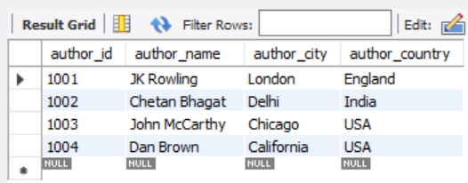

INSERT INTO publisher VALUES(2001,'Bloomsbury','London','England');

INSERT INTO publisher VALUES(2002,'Scholastic','Washington','USA');

INSERT INTO publisher VALUES(2003,'Pearson','London','England');

INSERT INTO publisher VALUES(2004,'Rupa','Delhi','India') ;

COMMIT;

SELECT * FROM publisher;

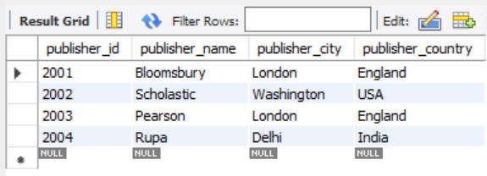

INSERT INTO category VALUES(3001,'Fiction');

INSERT INTO category VALUES(3002,'Non-Fiction');

INSERT INTO category VALUES(3003,'Thriller');

INSERT INTO category VALUES(3004,'Action');

INSERT INTO category VALUES(3005,'Fiction');

COMMIT;

SELECT * FROM category;

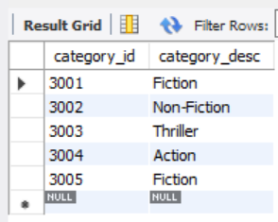

INSERT INTO catalog VALUES(4001,'HP and Goblet Of Fire',1001,2001,3001,2002,600);

INSERT INTO catalog VALUES(4002,'HP and Order Of Phoenix',1001,2002,3001,2005,650);

INSERT INTO catalog VALUES(4003,'Two States',1002,2004,3001,2009,65);

INSERT INTO catalog VALUES(4004,'3 Mistakes of my life',1002,2004,3001,2007,55);

INSERT INTO catalog VALUES(4005,'Da Vinci Code',1004,2003,3001,2004,450);

INSERT INTO catalog VALUES(4006,'Angels and Demons',1004,2003,3001,2003,350);

INSERT INTO catalog VALUES(4007,'Artificial Intelligence',1003,2002,3002,1970,500);

COMMIT;

SELECT * FROM catalog;

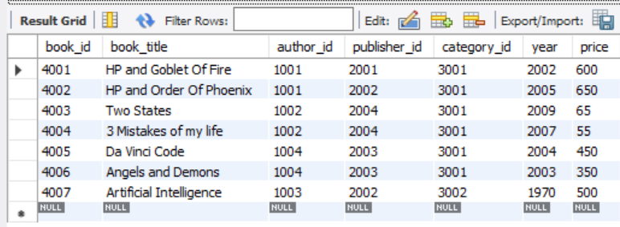

INSERT INTO order_details VALUES(5001,4001,5);

INSERT INTO order_details VALUES(5002,4002,7);

INSERT INTO order_details VALUES(5003,4003,15);

INSERT INTO order_details VALUES(5004,4004,11);

INSERT INTO order_details VALUES(5005,4005,9);

INSERT INTO order_details VALUES(5006,4006,8);

INSERT INTO order_details VALUES(5007,4007,2);

INSERT INTO order_details VALUES(5008,4004,3);

COMMIT;

SELECT * FROM order_details;

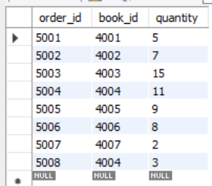

QUERIES:

1. Give the details of the authors who have 2 or more books in the catalog and the price of the books is greater than the average price of the books in the catalog and the year of publication is after 2000.

SELECT * FROM author

WHERE author_id IN

(SELECT author_id FROM catalog

WHERE year>2000 AND price>(SELECT AVG(price) FROM catalog)

GROUP BY author_id HAVING COUNT(*)>1);

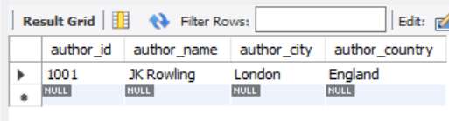

1. Find the author of the book which has maximum sales.

SELECT a.author_name FROM author a,catalog c WHERE a.author_id=c.author_id AND book_id IN (SELECT book_id FROM order_details WHERE quantity = (SELECT MAX(quantity) FROM order_details));



1. Demonstrate how you increase the price of books published by a specific publisher by 10%.

SET SQL_SAFE_UPDATES = 0;

UPDATE catalog SET price=1.1*price

WHERE publisher_id IN

(SELECT publisher_id FROM publisher WHERE publisher_name='pearson');

SELECT * FROM catalog;

SET SQL_SAFE_UPDATES = 1;

